Ivan Cruz

Prof. Waziri

IT-520

March 20, 2018

Lab 5

* Took screenshot of tracert www.weawards.com.au

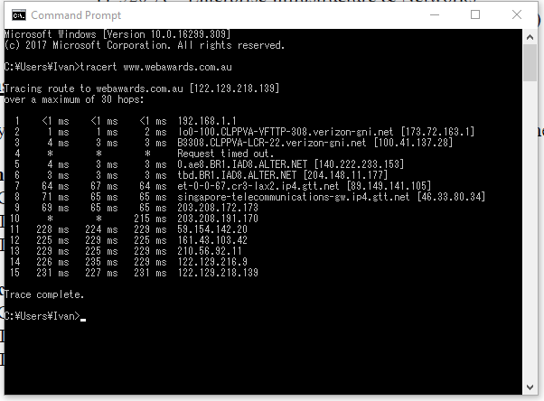

1. The IPv4 of my computer is 192.168.1.4
2. The first ping was my computer sending a packet to my router (IPv4 192.168.1.1)
3. The second ping is my router sending a packet to my local Internet Service Provider (ISP) (IPv4 173.72.163.1)

|  |  |  |  |
| --- | --- | --- | --- |
| Hop Count | IP address | Organization | Location |
| 1 | 192.168.1.1 | Ivan’s Router | Culpeper, Virginia/ USA |
| 2 | 173.72.163.1 | Local ISP/Verizon | Culpeper, Virginia/USA |
| 3 | 100.41.137.28 | Verizon Business | Ashburn, Virginia/USA |
| 4 | Request timed out |  |  |
| 5 | 140.222.233.153 | ANS CO+RE Systems, Inc | Purchase, NY/USA |
| 6 | 240.148.11.177 | Internet Assigned Numbers Authority | Los Angeles, CA |
| 7 | 89.149.141.105 | GTT | Baden-Württemberg/Germany |
| 8 | 43.33.80.34 | Chiyoda-ku | Tokyo/Japan |
| 9 | 203.208.172.173 | Singapore Telecommunications | Central Singapore/Singapore |
| 10 | Timed out |  |  |
| 11 | 203.208.191.170 | Singapore Telecommunications | Central Singapore/Singapore |
| 12 | 161.43.103.42 | Optus | Victoria/Australia |
| 13 | 210.56.92.11 | NBN, IPWAN, MPLS & ADSL broadband tech | Victoria/Australia |
| 14 | 122.129.216.9 | Po Box 2007 St Kilda West (webawards physical location) | Victoria/Australia |
| 15 | 122.129.216.139 | Po Box 2007 St Kilda West (webawards) | Victoria/Australia |

1. The tracert command was used in this lab to send and observe the path the packet of information took from my computer to the destination ([www.webawards.com.au](http://www.webawards.com.au)). The packet went from my computer to my router which was then directed to my ISP. The ISP sent the packet to ANS (Advance Network Systems) an organization located in New York. I found it weird that the packet went up north to New York then was directed to California, I would have thought the packet would have been sent to Canada or directly to Germany. From Germany, the packet went to Japan then to Singapore and finally to Australia.

After googling Internet Assigned Numbers Authority (IANA), I now realize that this is the organization that deals with global IP allocation which makes sense why the packet crossed the country then back across.

